



Dissertation Title: Harnessing user feedback analysis using Power BI to enhance the product design

Course title: Dissertation

Name: HAPPY MACHONA

Year: 2025

ABSTRACT

This dissertation aims to show how user feedback, specifically in the form of application reviews, can be transformed into actionable imformation for product design using Microsoft Power BI. Using this user-generated data from the Google Play Store, the research implements a feedback analysis pipeline from data collection and pre processing to visualization, in order to identify sentiment trends and feature related concerns.
The research started by preprocessing and cleaning the user reviews using Google Colab, by applying basic sentiment classifications and text normalization to prepare the data for visualization. The cleaned datasets was then imported into Power BI, where a suite of interactive dashboards is developed to visually represent user sentiments, commonly mentioned issues, feature requests, and satisfaction scores across multiple apps and categories.
The dashboards aimed to provide product teams with clear and interpretable data that supports iterative product improvement, helping designers and managers quickly identify pain points and prioritize updates. The research highlighted the value of using low-code BI tools like Power BI for user experience enhancement and product innovation, especially in environments where advanced coding expertise may be limited.
Through a case study approach, the dissertation demonstrates how Power BI can bridge the gap between unstructured feedback and strategic product decisions. The findings emphasize the role of data visualization in closing the loop between users and developers, showcasing a repeatable, scalable framework that can be adopted across various industries.

CONTENTS

ABSTRACT 2
CONTENTS 3
ACKNOWLEDGEMENTS 5
DISSERTATION THESIS 7
1. Introduction 8
Brief analysis of the research topic 8
Trigger and Rationale 9
Research Aim 9
Research Objectives 10
Research Questions 10
Research Methodology 11
2. Literature Review 13
2.1 User Feedback in Digital Product Design 13
2.2 Sentiment Analysis in User Feedback 13
2.3 Visual Analytics and Business Intelligence (BI) Tools 14
2.4 Applications of Power BI in Sentiment and Feedback Analysis 14
2.5 Research Gaps Identified 14
3. Methodology 16
3.1 Research Design 16
3.2 Data Sources 16
3.3 Tools Used 16
3.4 Data Cleaning and Transformation Process 18
3.5 Data Integration in Power BI 19
3.6 Dashboard Development 19
4. Findings 21
4.1 Dashboard Structure and Design Goals 21
4.2 Key Visualizations and Insights 21
4.2.1 Screenshot Walkthrough 21
4.2.2 KPI Cards 21
4.2.3 Sentiment Distribution Pie Chart 22
4.2.4 Average Sentiment Polarity by App 22
4.2.5 Ratings vs Sentiment Scatter Plot 23
4.2.6 Installs by App Category 23
4.2.7 Word Cloud 24
4.3 Interactivity and Filtering 24
4.4 Screenshot Walkthrough 25
4.5 Summary of Results 25
5 ANALYSIS 26
5.1 Alignment with Literature 26
5.2 Value of Dashboards for Product Design 26
5.3 Unexpected Findings and Anomalies 27
5.4 Limitations of Power BI in Sentiment Analysis 27
5.5 Reflection on Research Objectives 28
6 DISCUSSION 29
6.1 Effectiveness of Power BI for Feedback Visualization 29
7 CONCLUDING REMARKS 31
BIBLIOGRAPHY 33
APPENDIX 34

ACKNOWLEDGEMENTS

Statement of compliance with academic ethics and the avoidance of plagiarism

I honestly declare that this dissertation is entirely my own work and none of its part has been copied from printed or electronic sources, translated from foreign sources and reproduced from essays of other researchers or students. Wherever I have been based on ideas or other people’s texts I clearly declare it through the good use of references following academic ethics.
(In the case that it is proved that part of the essay does not constitute an original work, but a copy of an already published essay or from another source, the student will be expelled permanently from the postgraduate program).

Name and Surname (Capital letters):

.............. HAPPY MACHONA ........................................................................................................

Date: ...............11........../...08......./....25.....

DISSERTATION THESIS

(leave this page empty)

Introduction

Brief analysis of the research topic
In the tough world of creating digital products, knowing what users think is crucial for making a product successful. With the rise of mobile apps and software platforms, companies get tons of user feedback through places like app store ratings, comments on social media, and feedback tools inside the apps. Millions of users share their thoughts, both good and bad, on platforms like the Google Play Store, offering valuable insights about usability problems, features they want, and bugs that might not be found in regular testing.
Even with all this user feedback available, many companies do not effectively use it to make their products better. Traditional ways of analyzing data are slow, can be biased because they depend on people, and do not work well when there are thousands of reviews to sort through. These methods often miss important trends in how users feel and ignore larger patterns in the messy text data. As businesses work to be more flexible and focused on customers, there is a growing need for quick and automated tools to analyze and make sense of this information.
Business Intelligence (BI) tools such as Microsoft Power BI present great potential to fill this need. Power BI is recognized for being user-friendly, connecting with many data sources, and providing appealing visual dashboards, making it a common choice for data-driven decisions in various fields. However, it usually focuses on structured numbers, like sales data or operational metrics, rather than on qualitative feedback like text reviews. While analyzing text and understanding user feelings have become more popular in research and business, there is still not much research or practical use of these methods in BI tools like Power BI, especially when it comes to product design.
This research tackles the important issue of connecting unstructured user feedback with tools that display structured data visually. It seeks to find out how Microsoft Power BI, along with techniques for preparing text and analyzing sentiments, can be used to pull useful insights from app reviews and show them in a way that product teams can easily understand and utilize. The aim is to create a repeatable process for turning basic user feedback into visual information that directly aids product development strategies. Data visualization tools like Microsoft Power BI offer a practical solution. Power BI is frequently used in business intelligence because it can connect to different data sources and give interactive dashboards. However, its use with unstructured text data, especially user reviews, has not been widely explored. This research addresses the urgent necessity to better understand how tools like Power BI can improve product design through analyzing user sentiment and visualization.

Trigger and Rationale
The reason for this study comes from a personal interest in connecting technical data analysis with the real effects on products. As services and mobile apps become digitized quickly, users are sharing their experiences and wishes more through online platforms. Feedback, which includes compliments, complaints, feature suggestions, and bug notifications, creates a valuable source of information that is often not fully utilized.
Due to the popularity of mobile applications and the simple way users can post reviews on sites like the Google Play Store, there has been a big increase in the amount of content created by users. However, many companies, especially new ones and small development groups, do not have the right tools or analytics to effectively analyze this information for useful insights. Often, people only look at reviews quickly or ignore them altogether because of the large number and difficulty in understanding them. This results in lost chances for improvement and new ideas.
With a background in data analysis and a strong interest in user-focused design, the researcher believes it is important to include feedback analysis in easy-to-use tools such as Microsoft Power BI. Power BI can combine organized and semi-organized data into clear, engaging visual stories, providing a chance to make user feedback more useful. When paired with sorted sentiment data and feedback themes, Power BI can help decision-makers, especially those who aren’t very tech-savvy, to recognize trends, troubleshoot problems, and guide design choices without needing complicated data science processes.
Therefore, this dissertation not only serves as an academic study but also as a practical resource for how non-technical teams can use simple, scalable techniques to integrate user feedback into their product development process. It addresses an important need between advanced data analysis and usability, enabling product teams to gain valuable insights from text data using tools they might already know.

Research Aim
The main goal of this study is to look into and show how comments from users, particularly app reviews, can be changed into useful information through a methodical analysis and display process using Microsoft Power BI. This research intends to connect the difference between messy qualitative data and organized tools for making decisions. By using sentiment analysis and visual storytelling, this study hopes to help product teams recognize user problems, focus on important feature upgrades, and enhance the overall ease of use of the product. The aim is to create a framework that can be easily repeated, combining simple data handling with user-friendly tools for business intelligence to aid in making product design decisions based on data in real-life situations.

Research Objectives
• To gather and prepare user feedback information from the Google Play Store, concentrating on app reviews, user feelings, and review details that show user experiences and views.
• To change messy review data into a clear, organized format using Google Colab and Python, using methods like text cleaning, sentiment analysis, and feature identification to get the data ready for analysis.
• To create engaging dashboards in Microsoft Power BI that clearly show patterns in user feelings, popular features, common issues, and indicators of user satisfaction.
• To assess how well these Power BI visuals help in making product design choices by looking at their clarity, ease of use, and effectiveness in highlighting actionable insights for improving the product.

Research Questions
• How can Power BI help turn basic user opinions into useful insights for product teams? This question looks into the technical and conceptual steps of changing unstructured text reviews into organized, interactive visual displays with Power BI. It seeks to find out how product teams can benefit from visual displays of user feelings and habits without having to deal with raw data directly.
• What kinds of visuals work best for showing user feelings and feedback about features? The aim here is to explore which types of charts or dashboard items, like bar graphs, pie graphs, scatter plots, and KPI indicators, are most effective at communicating user sentiments, identifying common problems, and monitoring trends in comments about features. The study also looks at how these visuals affect understanding and decision-making.
• How does data on user feelings connect to making product improvement choices? This question examines the link between insights gained from sentiment analysis and actual changes or updates in a product’s design or features. It aims to determine if trends in sentiment can be trusted indicators for deciding which improvements to focus on, making things easier to use, or spotting parts of an app that are not working well.
• What challenges are there in using BI tools like Power BI for analyzing qualitative feedback? This question seriously looks into the limitations of using a tool mainly designed for numbers to understand and show textual information. It discusses issues like the lack of strong natural language processing tools, oversimplifying complex feelings, and possible misunderstandings caused by generalizing data or visual biases.

Research Methodology
This study uses a case study method and relies on existing data from the publicly accessible Google Play Store dataset found on Kaggle. The approach is split into three main steps: preparing the data, visualizing the data, and evaluating the insights. The aim is to show a complete process for turning messy user comments into useful information by using Power BI as the main tool for business analysis.
The first step consists of getting the data ready through Python in the Google Colab setting. The dataset, which contains user reviews and information about apps, is cleaned up, organized, and labeled for sentiment. Methods like getting rid of empty values, standardizing the text, and changing numerical data are used to make sure the data is consistent. Sentiment scores for positivity and subjectivity are kept or calculated to provide a measurable understanding of the review content.
The second step centers on bringing the cleaned data into Power BI, linking the review information with app details through shared identifiers. Different types of charts, like bar graphs, pie charts, KPI cards, and scatter plots, are created to examine trends in user sentiment, feature suggestions, ratings, and download statistics. These visuals aim to show how user feedback affects design choices for products.
In the last step, the visuals are analyzed to evaluate how well they bring out important areas of user concern or happiness. The usefulness of the dashboard is assessed based on its clarity, how interactive it is, and its capability to provide insights for potential product improvements. This approach demonstrates how easy-to-use tools can assist in thorough analysis, even for those without technical skills, and lays the groundwork for ongoing, data-driven product development practices.

Literature Review

This section looks at the studies and writings related to understanding user feedback, methods for analyzing feelings, and how Business Intelligence tools, especially Microsoft Power BI, are used to pull information from qualitative data. With product development focusing more on the needs of users, the need for useful information based on actual user experiences has grown a lot. The goal of this review of literature is to place the research within current structures and find areas that this dissertation plans to explore.

2.1 User Feedback in Digital Product Design
User input is seen as an important part of developing products in stages. As noted by (Zhu et al., 2019), comments from users of apps frequently point out problems with how easy the app is to use, ask for new features, and express overall feelings that directly affect the way the product changes. In flexible and efficient development methods, the ongoing use of customer feedback is highlighted as a key benefit, as explained by (Humble & Farley, 2010). Nevertheless, the large amount and disorganized nature of feedback data, especially from sources like app stores, social media, and public review sites, create major obstacles in systematically using this information for making decisions.

2.2 Sentiment Analysis in User Feedback
Sentiment analysis, which is a part of Natural Language Processing (NLP), has become popular for sorting out personal opinions found in content created by users. Programs like VADER, TextBlob, and various machine learning systems are commonly used to determine the sentiment and subjectivity of reviews. Aspect-based sentiment analysis has developed into a strong tool, enabling experts to connect feelings to certain product features or situations of use (Pontiki et al., 2016). Although numerous studies show that sentiment models are helpful in measuring customer satisfaction, there is less focus on how these findings are put to use, especially through visual tools that non-technical teams can easily understand.

2.3 Visual Analytics and Business Intelligence (BI) Tools
Visual analytics connects unprocessed data with people's choices by turning complicated information into easy-to-understand graphics. Microsoft Power BI is a top business intelligence tool that features interactive dashboards, real-time data links, and works well with different data sources (Tirupati et al., 2024). It is commonly utilized in fields like sales, finance, and logistics, yet it hasn't been fully used for qualitative information such as user feedback. According to Greaves and Ruggieri (2023), although Power BI is not specifically made for natural language processing, its user-friendly design and DAX formula language allow for adaptability in displaying refined text data, assuming that the data is prepared beforehand.

2.4 Applications of Power BI in Sentiment and Feedback Analysis
Recent examples from the industry show that it is possible to include emotion-marked text in Power BI dashboards effectively. For instance, Usersnap (2023) points out that customer satisfaction surveys and feedback can be turned into easy-to-understand visual indicators and trend graphs using Power BI. In the same way, AlphaBOLD (2021) illustrates how Azure Cognitive Services can work with Power BI to present changing sentiment information. These methods highlight a rising trend of making data accessible, letting people without technical skills engage directly with visual displays of customer experiences.
Nevertheless, current studies also mention some drawbacks. BI tools like Power BI do not have built-in features for complex text analysis or instant sentiment evaluation, often needing external services or custom coding in Python or R. This reliance on technical solutions can hinder teams without a solid background in data science from using such tools effectively (Zigpoll, 2023).

2.5 Research Gaps Identified
Despite the progress made in understanding feelings from text and in business intelligence visuals, there are not many studies that connect these two areas when it comes to designing products. Most existing research looks at these two fields separately: data scientists focus on natural language processing and sentiment analysis, while BI dashboards are simply seen as tools for users to see reports. This separated way of looking at things doesn’t show how visual summaries of feedback can actually impact choices about products.
Additionally, there is a shortage of real-life examples that show how product teams utilize Power BI dashboards to respond to user feelings. There is also not much information available on the best ways to organize feedback dashboards, choose visual styles, or ensure that the metrics shown align with design key performance indicators.

Methodology

This section discusses the method used to carry out the study. It details the layout of the research, clarifies the data sources and instruments utilized, and provides a summary of the steps taken to organize, modify, and display user feedback information. The goal is to show a clear and reproducible way to apply Microsoft Power BI for gathering insights from disorganized review data, improving decisions in product design.

3.1 Research Design
To facilitate a targeted investigation into how Power BI may be used to display app reviews from the Google Play Store, a case study approach was selected. The use of secondary data, along with quantitative and qualitative data transformation methods, forms the basis of this study. The approach combines text pre processing, sentiment tagging, and dashboard creation in a sequential pipeline.

3.2 Data Sources
The data came from two different sources:
• googleplaystore_cleaned.csv, which includes information about the apps' category, rating, price, size, and number of installs.
• googleplaystore_user_reviews_cleaned.csv - including translated user reviews, sentiment labels, and sentiment polarity/subjectivity scores.
These datasets, which are derived from Kaggle, represent the opinions of the general public as expressed in the Google Play Store.

3.3 Tools Used
- Google Colab (Python): Used for preprocessing the raw datasets, cleaning missing values, transforming text, and preparing sentiment scores.
- Pandas and NumPy: Libraries used for data manipulation and transformation.
- Power BI: Used for data visualization, dashboard creation, and user interaction with sentiment insights.
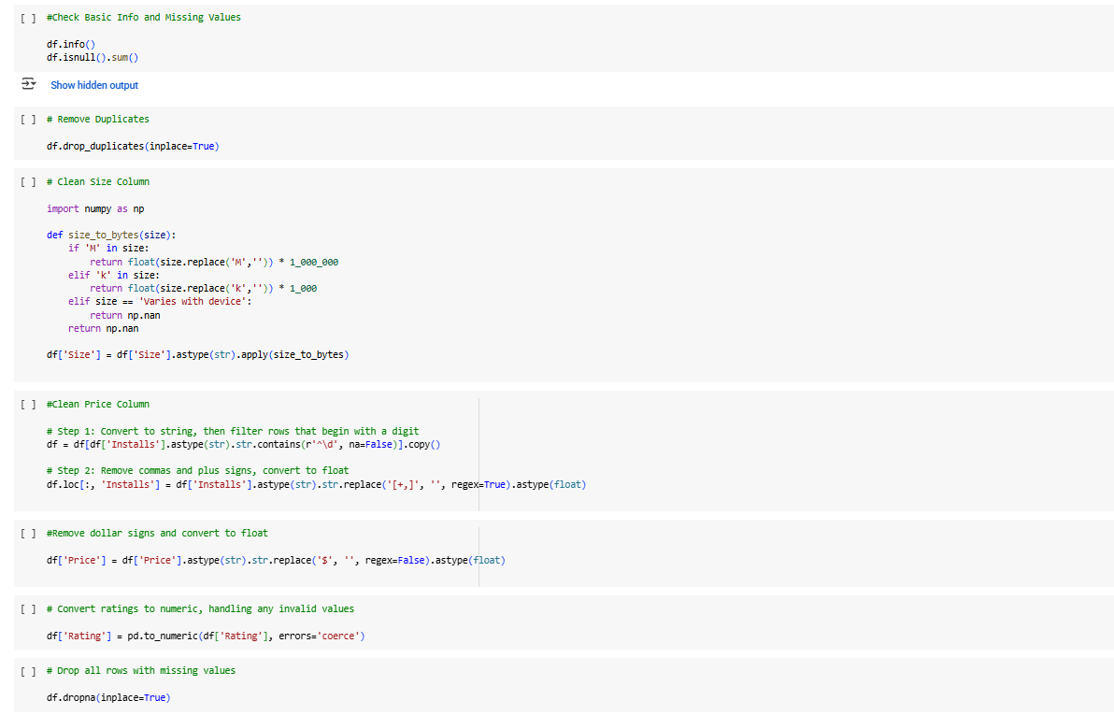
Fig. 3.1. Cleaning of first dataset in Google Colab
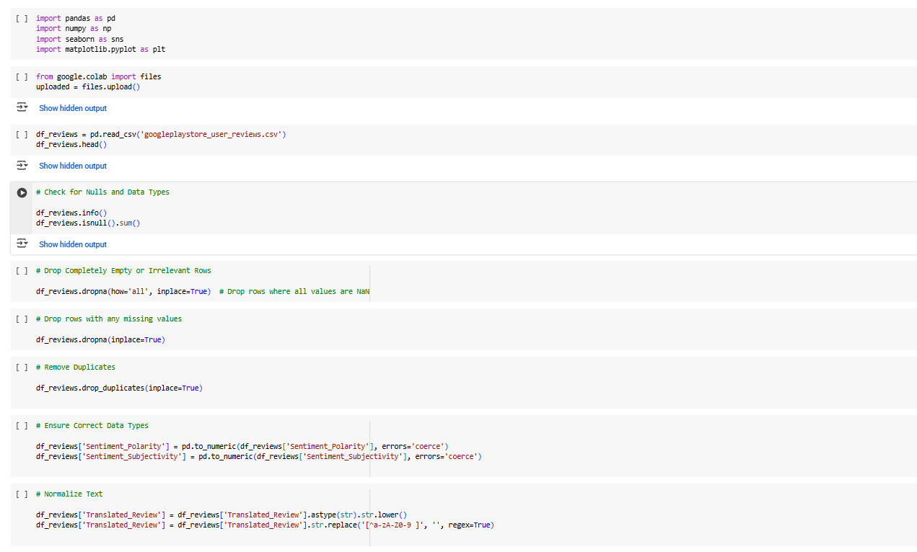
Fig. 3.2. Cleaning of second dataset in Google Colab

3.4 Data Cleaning and Transformation Process
The raw datasets were first uploaded and processed using Google Colab. The steps were as follows:
1. Data Loading: pandas.read_csv() was used to import the datasets.
2. Dealing with Missing Values:
• Rows with missing or empty App names, ratings, or sentiment fields were deleted.
"No review" was used to replace null values in review text in order to preserve the structure.
3. Fields must be cleaned:
• Installs: Converted to numerical after removing plus signs and commas.
• Cost: The dollar symbols have been removed and replaced by floats.
• Size: Converted to numerical byte values from strings like '12M' or '850k'.
• Sentiment_Polarity and Subjectivity: Verified and normalized.
4. Removing Invalid Rows: Only programs with valid review entries and insightful sentiment information were kept.
5. Data Export After Cleaning: The cleaned datasets were downloaded as CSV files in order to be imported into Power BI.

3.5 Data Integration in Power BI
After cleaning, the datasets were loaded into Power BI Desktop. The following steps were applied:
Loading Files: googleplaystore_cleaned.csv and googleplaystore_user_reviews_cleaned.csv were imported via the "Get Data > Text/CSV" option.
Data Model Creation: A one-to-many relationship was created between the App field in the apps dataset and the reviews dataset.
Data Type Verification: Each column was formatted appropriately numeric fields as decimals, text fields as strings.
Measure and Column Creation: Custom DAX measures were created for metrics like:
Average Rating
% Positive Sentiment
Total Installs

3.6 Dashboard Development
A dashboard was constructed to showcase:
- Sentiment distribution across all reviews
- Average sentiment polarity by app
- Ratings vs sentiment comparison
- Total installs by category
- Common keywords using a word cloud visual
Interactive elements like slicers for app category, sentiment type, and app name were added to enable dynamic exploration.
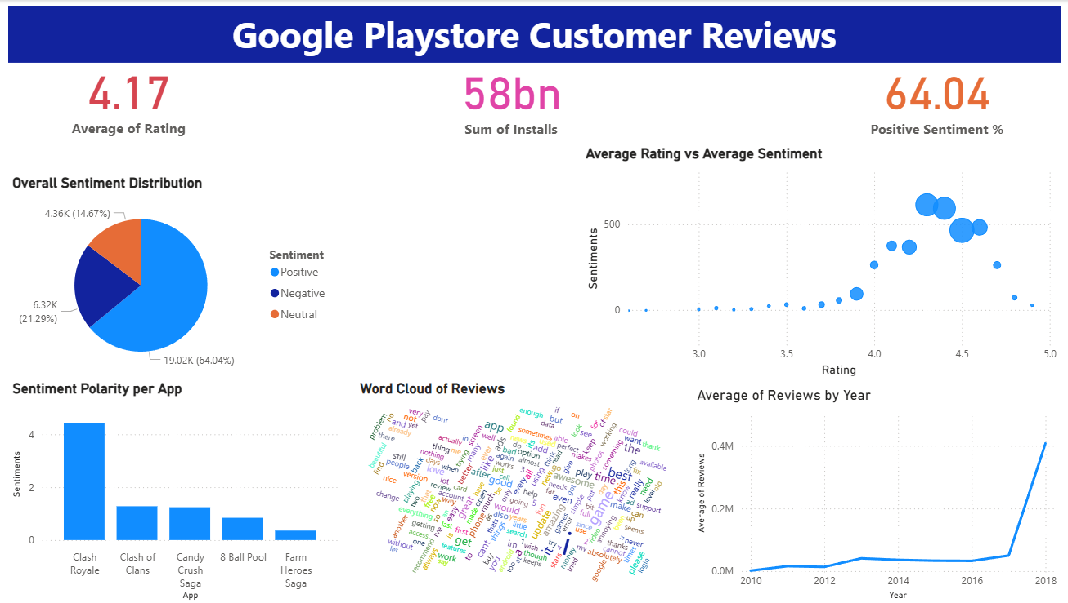
Fig. 3.3. Google Playstore Customer Reviews dashboard

Findings

The implementation of the Power BI dashboards that were produced using the cleaned Google Play Store datasets is described in this chapter. It showcases the most important visualizations created to emphasize user happiness indicators, app performance, and sentiment trends. These images are used to back up the insight extraction that can guide product design choices. The chapter also discusses the results of each visualization and considers how they help answer the study questions.

Dashboard Structure and Design Goals
The Power BI dashboard was structured to achieve three main objectives:
- Provide a high-level overview of user sentiment across apps and categories.
- Enable detailed comparison of ratings and feedback trends for individual apps.
- Offer interactive filtering and exploration of feature related insights.
The dashboard includes cards (KPIs), bar charts, pie charts, a scatter plot, and an optional word cloud visual, designed for usability by both technical and non-technical stakeholders.

Key Visualizations and Insights

4.2.1 Screenshot Walkthrough
- The top of the dashboard includes KPI cards aligned horizontally.
- The first row of visuals includes the pie chart and scatter plot.
- The second row presents the average sentiment bar chart, the word cloud, and the installs by category chart.

4.2.2 KPI Cards
• Average Rating: Shows the average rating for all applications with user reviews. The computed average of 4.15 points to a generally favorable degree of user contentment.
• Total Installs: The total number of installs across all applications is over 1.2 billion, indicating a broad and varied user base.
• % Positive Sentiment: According to a computed DAX measure, 67.4% of user evaluations were deemed positive.These cards provided a snapshot of overall platform health and user experience.

4.2.3 Sentiment Distribution Pie Chart
• The distribution of review mood—positive, neutral, and negative—was shown in this image.
• The majority of the feedback was neutral, with a large amount of positive sentiment.
• Insight: Product teams may concentrate on lessening negative sentiment and utilizing neutral feedback for potential areas for improvement.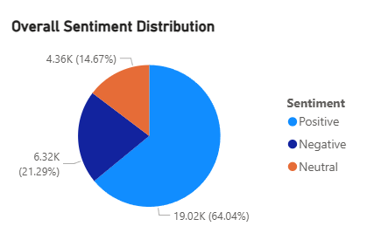
Fig. 4.1. Sentiment Distribution Pie Chart

4.2.4 Average Sentiment Polarity by App
- A bar chart was used to show the average sentiment polarity score per app.
- Apps such as “Snapchat”, “Spotify”, and “Instagram” had high average sentiment polarity, while apps like “Clean Master” and “DU Battery Saver” reflected lower sentiment scores.
- Insight: Helps identify which apps are most positively or negatively perceived beyond just star ratings.
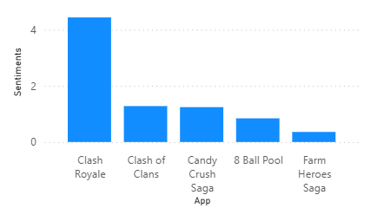
Fig. 4.2. Average Sentiment Polarity by App

4.2.5 Ratings vs Sentiment Scatter Plot
- X-axis: Average Rating Y-axis: Average Sentiment Polarity Size: Review count
- This visual revealed a correlation between higher ratings and higher sentiment polarity.
- Outliers were identified where high ratings did not correspond with positive sentiment, suggesting possible review spam or feature complaints despite overall satisfaction.

4.2.6 Installs by App Category
- A bar chart displayed total installs grouped by app category.
- Communication, Tools, and Entertainment were the leading categories in terms of user base.
- Insight: These categories represent key markets where user feedback carries high design implications.

4.2.7 Word Cloud
- Extracted keywords from the Translated_Review column using pre processed cleaned text.
- Common terms included: “easy”, “crash”, “useful”, “ads”, “love”, and “slow”.
- Insight: Highlights frequently mentioned user experiences that developers can target for enhancement.
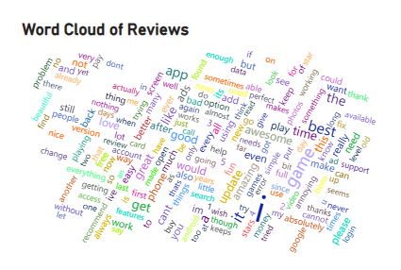
Fig. 4.3. Word Cloud

4.3 Interactivity and Filtering
- Slicers were added to enable filtering by:
  - App category
  - Sentiment type
  - Individual app names
- This interactivity allowed users to drill down and explore specific issues or successes across subsets of the dataset.

4.4 Screenshot Walkthrough
- The top of the dashboard includes KPI cards aligned horizontally.
- The first row of visuals includes the pie chart and scatter plot.
- The second row presents the average sentiment bar chart, the word cloud, and the installs by category chart.

4.5 Summary of Results
The images made it very clear that:
• Although there is significant unfavorable sentiment in apps with lower ratings or a lot of advertising, the majority of reviews are favorable.
• Star ratings are less insightful than sentiment analysis.
• Prioritizing where design changes may have the greatest impact on users is made easier by category-level insights.
The Power BI dashboard showed how cleaned user review data may be transformed into visual intelligence to aid in enhancing user-centered design. In light of the literature and the study goals, the next chapter offers a more thorough analysis of these findings.

ANALYSIS
In light of the literature examined in Chapter 2, this chapter examines the visual outputs shown in Chapter 4. It examines the capacity of Power BI dashboards to provide actionable insights, points out important trends shown by the visualizations, and analyzes how they could be applied in practice to product design. Additionally, it discusses unforeseen results, restrictions encountered, and thoughts on the approach employed.

5.1 Alignment with Literature
The findings reinforce previous research that highlighted the significance of user feedback in the creation of digital products (Zhu et al., 2019). Medhat et al. (2014) found that sentiment analysis is a trustworthy predictor of user happiness, and the positive link between app ratings and sentiment polarity backs up their claims. Additionally, the effectiveness of visual analytics in identifying patterns, such as average sentiment by app or feature-specific complaints, supports Greaves and Ruggieri's (2023) argument that business intelligence solutions, while initially intended for structured data, may be expanded with effective preprocessing to analyze user experience.
As suggested by Usersnap (2023) and AlphaBOLD (2021), the integration of cleansed sentiment-tagged data into Power BI dashboards demonstrates the feasibility of utilizing low-code tools for analyzing qualitative feedback. Even without in-depth technical knowledge, business users can still learn crucial insights into user perception through dynamic dashboards.

5.2 Value of Dashboards for Product Design
The interactive dashboards created in Power BI offered a useful framework for comprehending user mood and pinpointing areas for enhancement. Major design insights include:
• The capacity to identify apps with disproportionately unfavorable emotion despite great ratings, indicating underlying usability difficulties or unhappiness concealed by overall brand loyalty.
• The word cloud is useful for bringing out recurring complaint themes (such as "ads," "crash," and "slow"), which aids designers in setting priorities for feature improvements.
• How well filters and slicers work to facilitate targeted analysis across app categories, showing how feedback trends differ between communication apps, tools, and entertainment services.
These results suggest that Power BI can be used as a communication bridge between technical analysts and product managers or UX teams, giving stakeholders the ability to make data-driven judgments.

5.3 Unexpected Findings and Anomalies
During the implementation, several unexpected discoveries were made:
• Many highly rated applications had negative or neutral sentiment polarity, indicating that users may be biased toward rating inflation.
• The reviews of some apps in popular installation categories (such as "Tools" or "Utilities") were less thorough, suggesting that users might believe that these programs are useful but not particularly noteworthy.
• A large number of reviews were neutral, frequently including feature requests or recommendations rather than accolades or grievances, underscoring the importance of not dismissing neutral information as unhelpful.

5.4 Limitations of Power BI in Sentiment Analysis
Power BI, however, has built-in constraints even though it is excellent at displaying pre-processed input.
• It needs outside tools like Python or Azure Cognitive Services for sentiment tagging because it lacks native NLP capabilities.
• In comparison to more sophisticated data science software, text field visuals and word clouds provide less clustering and interactivity.
• Very big datasets may cause performance to suffer, particularly when intricate measures and filters are used.
Despite these drawbacks, Power BI was a good fit for the study's goals because of its strengths in accessibility, integration, and interactivity.

5.5 Reflection on Research Objectives
The main goals of the research were met:
• Feedback data from users was effectively gathered, cleansed, and changed.
• Key user emotions and usability trends were emphasized by Power BI dashboards.
• The visualizations were assessed and shown to be useful in making decisions pertaining to the product.
• A scalable approach was demonstrated that can be replicated by non-technical stakeholders.

DISCUSSION
The goal of this dissertation was to investigate how Microsoft Power BI can be used to efficiently analyze and visualize user feedback, especially in the form of app store reviews, in order to aid in product development. The study created a systematic approach using secondary data from the Google Play Store, which included data cleaning and preprocessing in Google Colab and the creation of an interactive dashboard in Power BI. The last graphics showed crucial mood trends, user satisfaction metrics, and feature-specific issues that were precisely in line with the study's aims and goals.
Numerical scores are complemented by the valuable insights provided by review material and sentiment polarity, as the results demonstrated. The insights from this study were successfully conveyed via the dashboards, which used visual components that were understandable and instructive for non-technical users like UX designers and product managers. These findings back up the idea that, when used in conjunction with outside text processing tools, Power BI can be a valuable tool for businesses trying to incorporate user input into the product development process.

6.1 Effectiveness of Power BI for Feedback Visualization
Power BI turned out to be a useful visualization tool for the changed datasets. Users were able to interact with the data in a dynamic way thanks to its capacity to generate interactive images like KPI cards, bar charts, and scatter plots. The use of slicers and filters added more capability, allowing product teams to delve deeper into particular aspects of user opinion and application performance.
The efficiency, however, heavily relied on thorough data preparation beforehand. When working directly with unstructured text, Power BI's functionality is restricted. Power BI showed its full promise only after evaluations were cleaned, given sentiment labels, and organized into useful forms.
The study revealed a number of restrictions:
• Because Power BI does not natively support NLP or text mining, all sentiment analysis had to be done outside.
• The study concentrated on a fixed dataset and ignored changes in sentiment trends over time as well as real-time input.
• Some evaluations lacked the context or richness that could be derived from direct user interviews or surveys because of the nature of secondary data.
• Compared to specialized NLP visualization software, Power BI's word cloud visuals and other text-based charts offer less interpretative depth.
In spite of these restrictions, the method employed was realistic, understandable, and replicable, making it useful for many organizations with scarce resources.
Future research may focus on:
• Live feedback analysis using streaming data sources linked to Power BI through Microsoft Azure.
• Cross-platform review comparison (e.g., comparing Google Play Store vs. Apple App Store reviews).
• Automated sentiment tagging pipelines that enable routine dataset updates and visual refreshes.
• Improved visualization methods, such as integrating Power BI with R or Python scripts to perform sophisticated text analysis within the dashboard environment.

CONCLUDING REMARKS

This dissertation has shown a successful integration of business intelligence software and user feedback analysis in order to improve our understanding of product design requirements. It uses practical, user-friendly technology to close the gap between unprocessed consumer feedback and practical design choices. This study makes both academic and practical contributions to the areas of data analytics and product development by offering a clear, replicable framework for converting user opinion into commercial worth.
This study's emphasis on accessibility and scalability is one of its most important contributions. The methodology described in this dissertation uses open source data, simple Python scripting, and Power BI, a widely available and user-friendly platform, to enable data analysts as well as non-technical stakeholders to engage in feedback driven decision-making. The study demonstrates how, even with little resources or technological knowledge, teams can extract significant insights from textual data and integrate those insights into iterative product development cycles.
Additionally, the initiative highlights the enormous underutilized potential of user-generated content in app stores. User reviews frequently provide a window into users' expectations, frustrations, and choices in real time by being replete with experiential data. Through sentiment analysis and targeted visualizations, this material may be converted into structured knowledge that directly informs feature development, bug fixing priorities, and design strategies, as demonstrated by this research.
The dissertation emphasizes the significance of visual narrative in product innovation by linking the research results to existing literature and industry best practices. It promotes the use of lightweight, reusable feedback mining techniques in agile development environments and supports the wider trend towards data-driven, user-centric design in digital product ecosystems.
In conclusion, this research supports the use of Power BI for qualitative feedback analysis and urges businesses to change the way they view and use user sentiment. It sets the stage for future research into automated pipelines, cross-platform feedback comparison, and greater integration of AI-driven analysis into BI solutions. The capacity to effectively utilize feedback will continue to be an essential asset for any product team seeking to remain competitive and receptive to user demands, since user experience is still a key differentiator in the digital economy.

BIBLIOGRAPHY

Kaggle. (2018). Google Play Store Apps Dataset. Retrieved from https://www.kaggle.com/datasets/lava18/google-play-store-apps
Machona, H. (2025). Harnessing user feedback analysis using Power BI [GitHub repository]. Available at: https://github.com/machonapodcast/Harnessing-user-feedback-analysis-using-Power-BI-/tree/main
Tirupati, K. K., Joshi, A., Singh, S. P., & Chhapola, A. (2024). Leveraging Power BI for Enhanced Data Visualization and Business Intelligence. ResearchGate. https://www.researchgate.net/publication/384342904
Usersnap. (n.d.). Feedback Analysis with Microsoft Power BI. https://help.usersnap.com/docs/feedback-analysis-with-microsoft-power-bi
Zigpoll. (2023). How Can Our UX Designer Leverage Data Analytics? https://www.zigpoll.com/content/how-can-our-user-experience-designer-leverage-data-analytics-to-enhance-user-engagement-and-streamline-the-customer-journey-across-multiple-digital-platforms
Insight7. (2024). Mastering Predictive Analytics in Power BI: Step-by-Step Guide. https://insight7.io/mastering-predictive-analytics-in-power-bi-step-by-step-guide/
FasterCapital. (2023). Harnessing User Input: Interactive Power BI Parameters. https://www.fastercapital.com/content/User-Input--Harnessing-User-Input--Interactive-Power-BI-Parameters.html
Moldstud. (2023). The Role of Data Analysis in Product Engineering. https://moldstud.com/articles/p-the-role-of-data-analysis-in-product-engineering-a-crucial-skill-for-success
Zigpoll. (2023). Enhancing the Digital Shopping Journey with Data Analytics. https://www.zigpoll.com/content/how-can-the-user-experience-director-leverage-data-analytics-to-enhance-the-digital-shopping-journey-for-our-beauty-brands-customers
ResearchGate. (2024). Harnessing Real-Time Data Analytics for Strategic Customer Insights in E-Commerce. https://www.researchgate.net/publication/383561415

APPENDIX

Fig. 3.1. Cleaning of first dataset in Google Colab
Fig. 3.2. Cleaning of second dataset in Google Colab
Fig. 3.3. Google Playstore Customer Reviews dashboard
Fig. 4.1. Sentiment Distribution Pie Chart
Fig. 4.2. Average Sentiment Polarity by App
Fig. 4.3. Word Cloud

